Universitatea Tehnică a Moldovei

 Facultatea Calculatoare Informatică și Microelectronică

Specialitatea Tehnologii Informaționale

**RAPORT**

la lucrarea de laborator nr. 2

la Programarea Aplicatiilor Mobile

A efectuat: Palii Dan Grupa TI-203

A verificat: Stamatin Alexandru

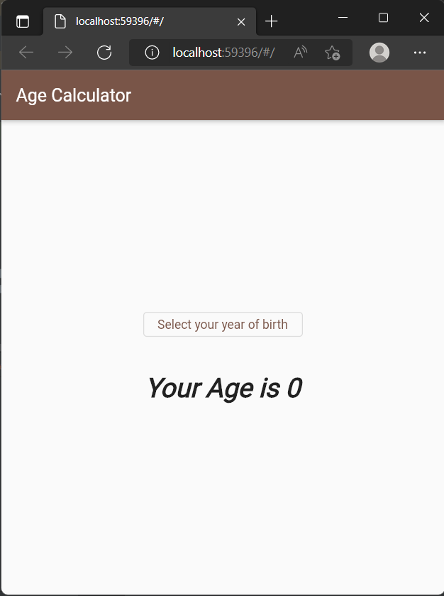

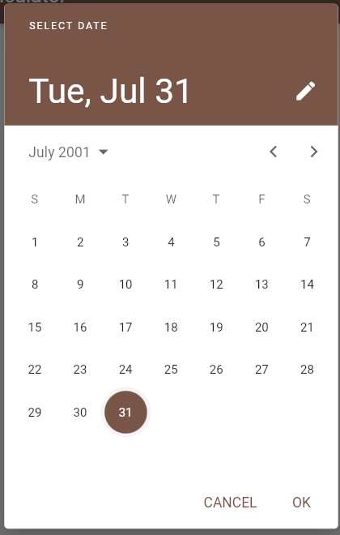

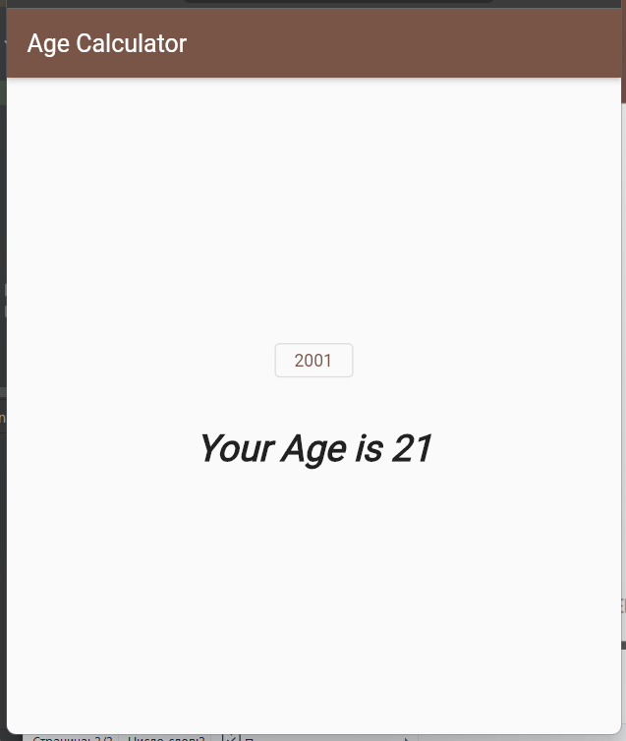

**Cod:**

import 'package:flutter/material.dart';  
  
void main() => runApp(new MaterialApp(  
 debugShowCheckedModeBanner: false,  
 theme: new ThemeData(primarySwatch: Colors.*brown*),  
 home: new MyHomePage()));  
  
class MyHomePage extends StatefulWidget {  
 @override  
 _MyHomePageState createState() => new _MyHomePageState();  
}  
  
class _MyHomePageState extends State<MyHomePage>  
 with SingleTickerProviderStateMixin {  
 double age = 0.0;  
 var selectedYear;  
 Animation animation;  
 AnimationController animationController;  
  
 @override  
 void initState() {  
 animationController = new AnimationController(  
 vsync: this, duration: new Duration(milliseconds: 1500));  
 animation = animationController;  
 super.initState();  
 }  
  
 @override  
 void dispose() {  
 // *TODO: implement dispose* //animationController.dispose();  
 super.dispose();  
 }  
  
 void _showPicker() {  
 showDatePicker(  
 context: context,  
 firstDate: new DateTime(1900),  
 initialDate: new DateTime(2018),  
 lastDate: DateTime.now())  
 .then((DateTime dt) {  
 selectedYear = dt.year;  
 calculateAge();  
 });  
 }  
  
 void calculateAge() {  
 setState(() {  
 age = (2022 - selectedYear).toDouble();  
 animation = new Tween<double>(begin: animation.value, end: age).animate(  
 new CurvedAnimation(  
 curve: Curves.*fastOutSlowIn*, parent: animationController));  
  
 animationController.forward(from: 1);  
 });  
 }  
  
 @override  
 Widget build(BuildContext context) {  
 return new Scaffold(  
 appBar: new AppBar(  
 title: new Text("Age Calculator", textAlign: TextAlign.center),  
 ),  
 body: new Center(  
 child: new Column(  
 mainAxisAlignment: MainAxisAlignment.center,  
 children: <Widget>[  
 new OutlinedButton(  
 child: new Text(selectedYear != null  
 ? selectedYear.toString()  
 : "Select your year of birth"),  
 // borderSide: new BorderSide(color: Colors.black, width: 3.0),  
 // color: Colors.white,  
 onPressed: _showPicker,  
 ),  
 new Padding(  
 padding: const EdgeInsets.all(20.0),  
 ),  
 new AnimatedBuilder(  
 animation: animation,  
 builder: (context, child) => new Text(  
 "Your Age is ${animation.value.toStringAsFixed(0)}",  
 style: new TextStyle(  
 fontSize: 30.0,  
 fontWeight: FontWeight.*bold*,  
 fontStyle: FontStyle.italic),  
 ),  
 )  
 ],  
 ),  
 ),  
 );  
 }  
}

GitHub:

https://github.com/danpalii/lab_pam.git